**PRACTICAL 12**

**Aim:** Installation of Selenium automated testing tool and Create Test Scripts in Selenium with Python. https://www.guru99.com/selenium-python.html

**Software Required:** python, selenium

**Theory:**

**What is Python?**

Python is a high-level object-oriented scripting language. It is designed in a user-friendly manner. Python uses simple English keywords, which is easy to interpret. It has less syntax complications than any other programming languages.

## What is Selenium?

Selenium is a tool to test your web application. You can do this in various ways, for instance

* Permit it to tap on buttons
* Enter content in structures
* Skim your site to check whether everything is "OK" and so on.

## Why to choose Python over Java in Selenium

Few points that favor Python over [Java](https://www.guru99.com/java-tutorial.html) to use with Selenium is,

1. Java programs tend to run slower compared to Python programs.
2. Java uses traditional braces to start and ends blocks, while Python uses indentation.
3. Java employs static typing, while Python is dynamically typed.
4. Python is simpler and more compact compared to Java.

## How to Install and Configure PyDev in Eclipse

PyDev is Python development environment for Eclipse.

**Step 1)** Got to Eclipse Marketplace. Help > Install New Software

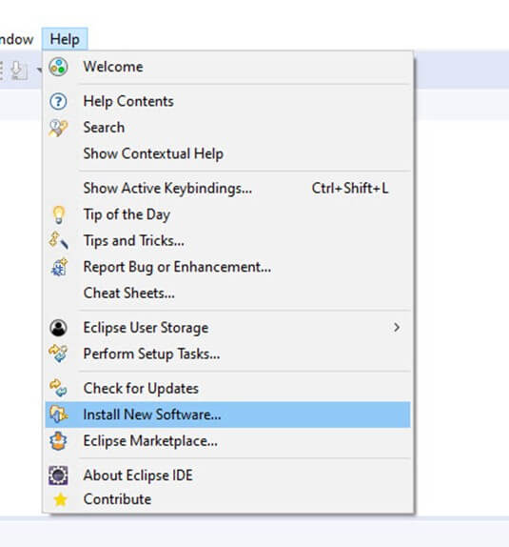

The next step is to install "pydev IDE" for eclipse.

**Step 2)**In this step,

1. Search for "http://pydev.org/updates" in Work with and then
2. Select all listed Items and click on Next twice
3. Accept the Licence Agreement and click Finish.

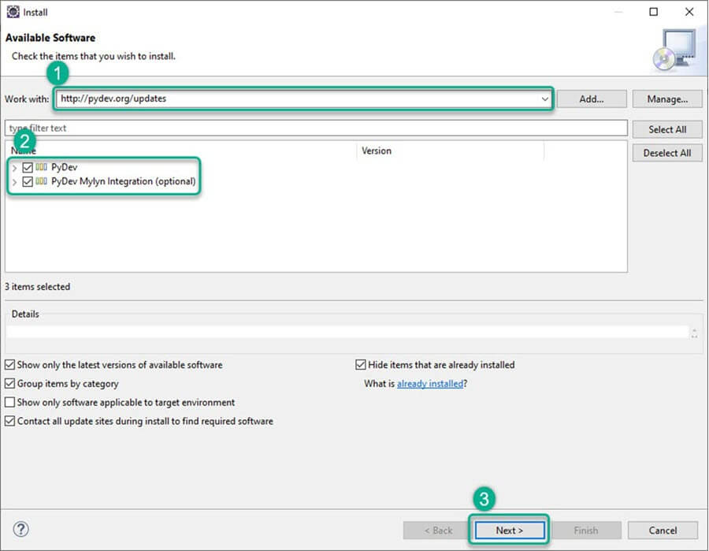

**Step 3)**You may encounter Security Warning, Click on "Install Anyway".

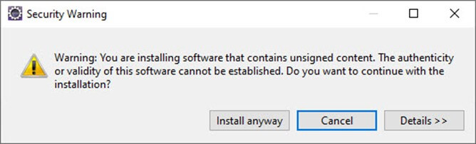

**Step 4)**Now**,**in this step you will set preferences. With the help of preference option, you can use Python as per the project need.

Go to Window > Preferences > PyDev > Interpreter > Python Interpreter.

[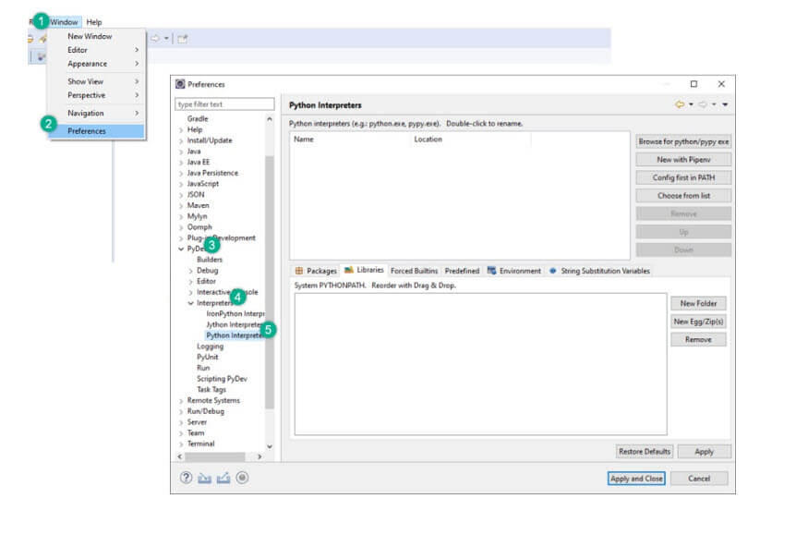](https://www.guru99.com/images/1/102219_1442_SeleniumWeb4.jpg)

Let's sets the default Python Interpreter. It is just like you need to set java compiler for running a Java code. To change the interpreter name, click on Browse for python/pypy exe Button.

[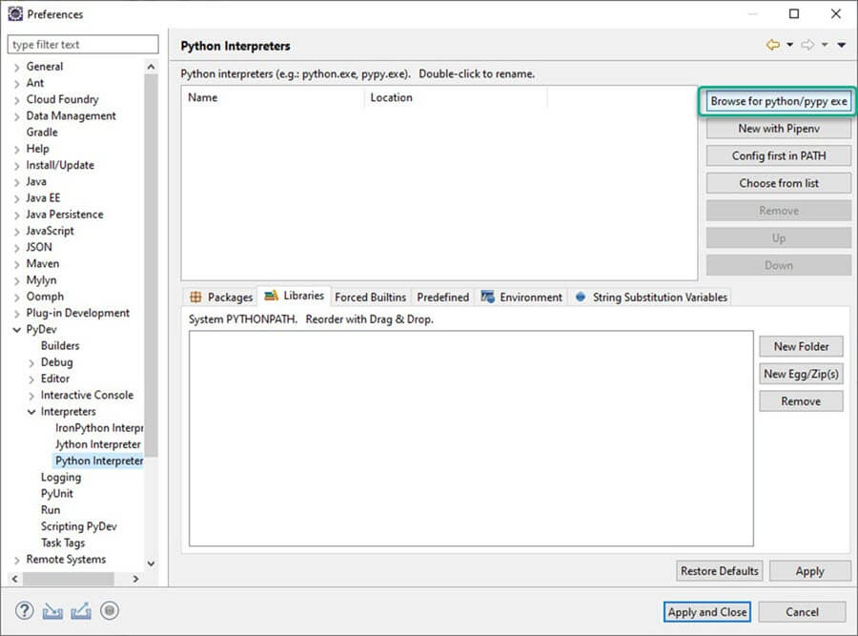](https://www.guru99.com/images/1/102219_1442_SeleniumWeb5.jpg)

**Step 5)**In this step, give the "interpreter name" and the "exe" file path of Python.

1. Click on 'Browse' and find python.exe where you installed python.
2. Click 'OK' button.
3. Select all the Folder and click on OK
4. Click on "Apply and Close".

[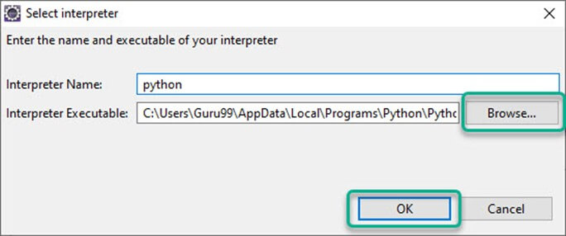](https://www.guru99.com/images/1/102219_1442_SeleniumWeb6.jpg)

**Step 6)** Make a New Project in Python. In this step,

1. Right click PyDev Package Explorer > New.
2. Select option others.

[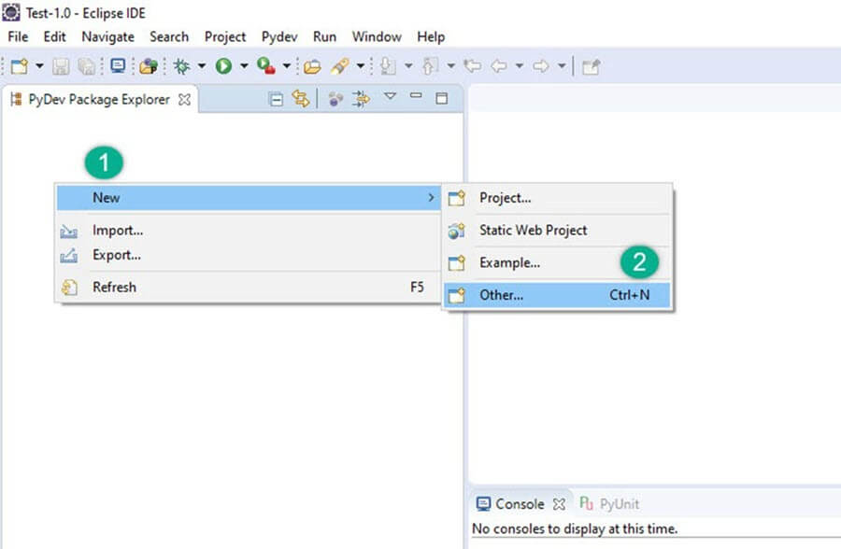](https://www.guru99.com/images/1/102219_1442_SeleniumWeb7.jpg)

1. Select "PyDev > PyDev Project".
2. Press 'Next' button.

[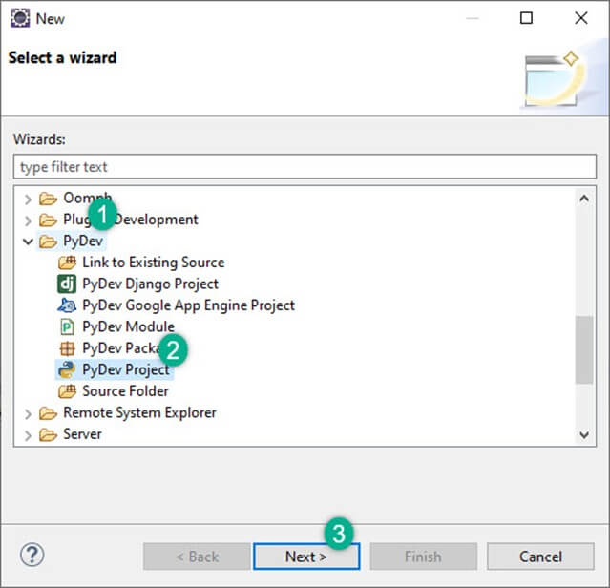](https://www.guru99.com/images/1/102219_1442_SeleniumWeb8.jpg)

1. Name your Project
2. Click "Finish".

[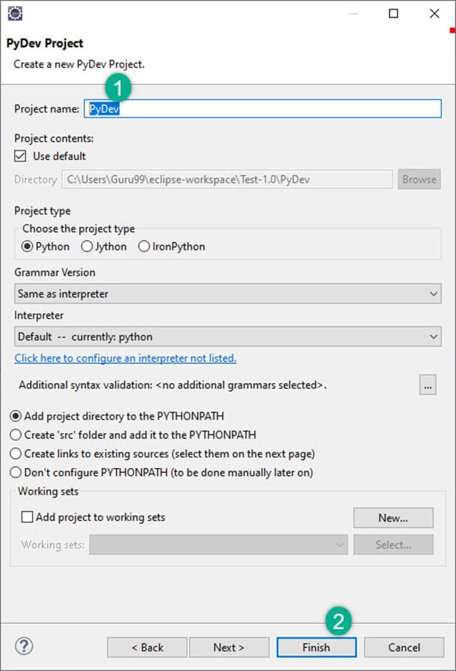](https://www.guru99.com/images/1/102219_1442_SeleniumWeb9.jpg)

You can see the new Python (PyDev) project is created.

**Step 7)**In this step,

After creating 'PyDev Project', you will create a new Python package.

1. Right click on Project > New > PyDev Package.
2. Name your Package and Click Finish.

[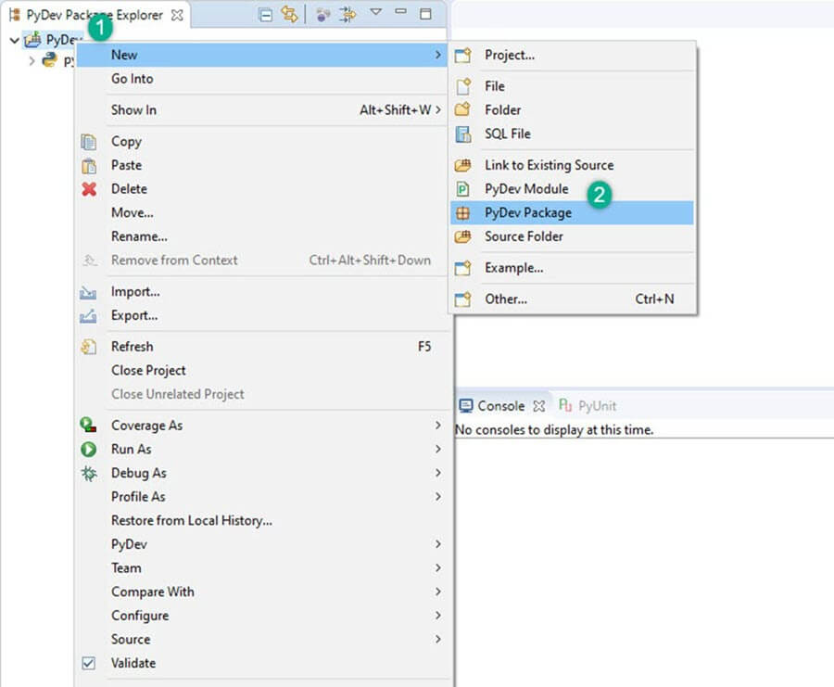](https://www.guru99.com/images/1/102219_1442_SeleniumWeb10.jpg)

[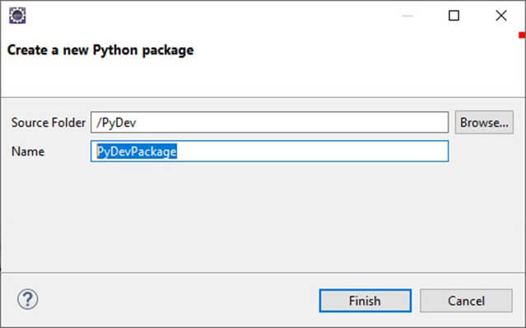](https://www.guru99.com/images/1/102219_1442_SeleniumWeb11.jpg)

**Step 8)** If you see in below screenshot, a new package is created.

[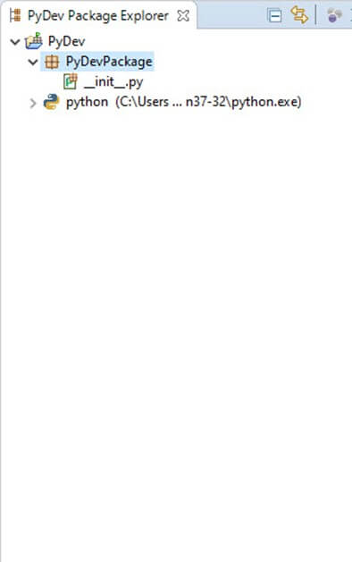](https://www.guru99.com/images/1/102219_1442_SeleniumWeb12.jpg)

After creating a new package, the next step is to createPyDev Module. The module contains somePython files for initialization. These files or functions from the module can be imported into other module. So, there will be no need to re-write the program again.

**Step 9)**  Createa new PyDev module. Right click on package > New > PyDev module.

[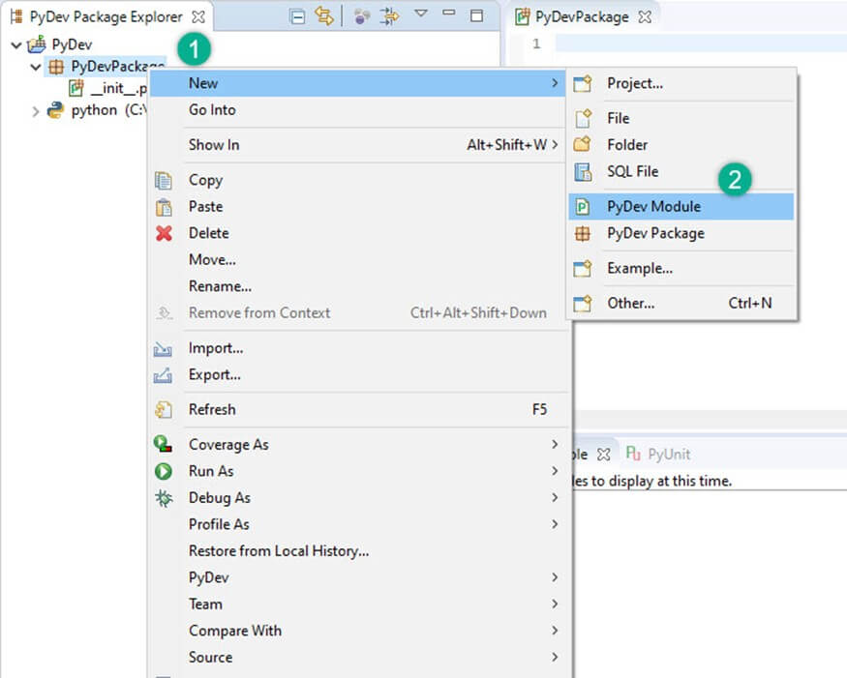](https://www.guru99.com/images/1/102219_1442_SeleniumWeb13.jpg)

Name your Module and click "Finish".

[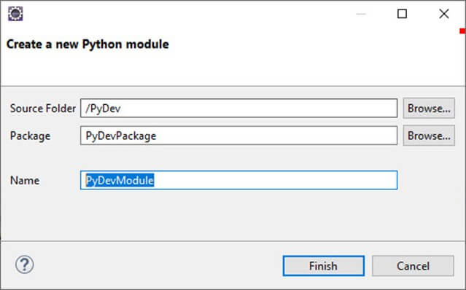](https://www.guru99.com/images/1/102219_1442_SeleniumWeb14.jpg)

Select Empty Template and Click "OK".

[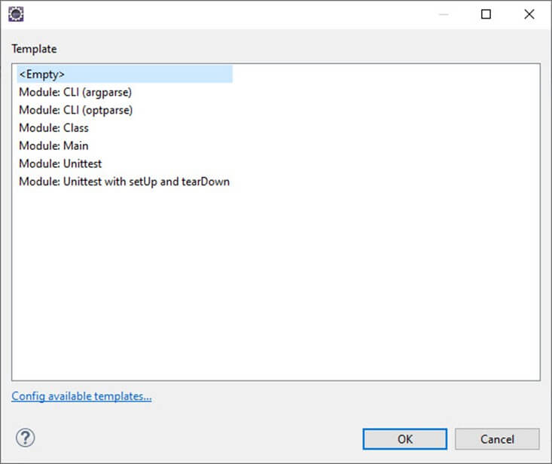](https://www.guru99.com/images/1/102219_1442_SeleniumWeb15.jpg)

**Step 10)** Write your Python code.

[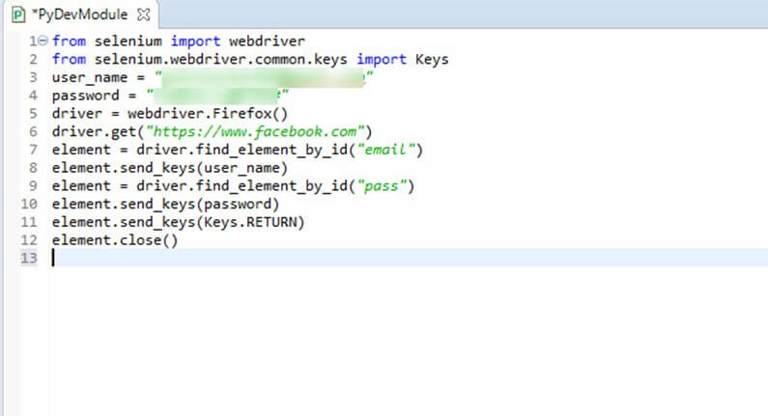](https://www.guru99.com/images/1/102219_1442_SeleniumWeb16.jpg)

## How to Create Test Scripts in Selenium with Python

In this example, we did automation for "Facebook login page" using the Firefox driver.

**EXAMPLE 1: Login into Facebook**

from selenium import webdriver

from selenium.webdriver.common.keys import Keys

user_name = "YOUR EMAILID"

password = "YOUR PASSWORD"

driver = webdriver.Firefox()

driver.get("https://www.facebook.com")

element = driver.find_element_by_id("email")

element.send_keys(user_name)

element = driver.find_element_by_id("pass")

element.send_keys(password)

element.send_keys(Keys.RETURN)

element.close()

**Snapshot of the Code**

[](https://www.guru99.com/images/1/102219_1442_SeleniumWeb17.jpg)

**Explanation of the code**

* **Code line 1**: From selenium module import webdriver
* **Code line 2**: From selenium module import Keys
* **Code line 3**: User is a variable which will be we used to store values of username.
* **Code line 4**: Variable "password" will be used to store values of the password.
* **Code line 5**: In this line, we are initializing "FireFox" by making an object of it.
* **Code line 6**: The "driver.get method" will navigate to a page given by the URL. WebDriver will wait until the page has been completely loaded (that is, the "onload" occasion has let go), before returning control to your test or script.
* **Code line 7**: In this line, we are finding the element of the textbox where the "email" has to be written.
* **Code line 8**: Now we are sending the values to the email section
* **Code line 9**: Same for the password
* **Code line 10**: Sending values to the password section
* **Code line 11**: element.send_keys(Keys.RETURN) is used to press enter after the values are inserted
* **Code line 12**: Close

**OUTPUT:**

The values of the username "guru99" and password entered.

[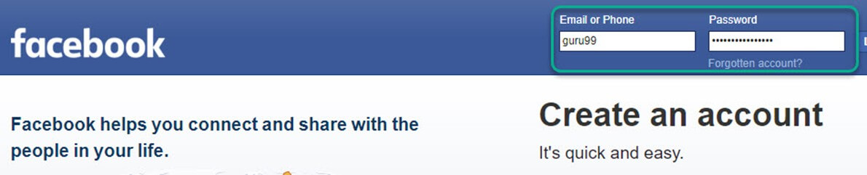](https://www.guru99.com/images/1/102219_1442_SeleniumWeb18.jpg)

The Facebook page will login with email and password. Page opened (see image below)

[](https://www.guru99.com/images/1/102219_1442_SeleniumWeb19.png)